PRODUCT FEATURE ANALYSIS – Medical App (SQL)
OBJECTIVE:
Analyze user interaction with key features, understand engagement, retention, and subscription patterns.
PROJECT SETUP:
-- Create database
CREATE DATABASE MedicalAppAnalytics;
GO
USE MedicalAppAnalytics;
GO
-- Users table
CREATE TABLE users (
user_id INT PRIMARY KEY,
signup_date DATE,
city VARCHAR(50),
device VARCHAR(50)
);
-- Feature events table
CREATE TABLE feature_events (
event_id INT PRIMARY KEY,
user_id INT,
event_date DATETIME,
feature_name VARCHAR(50),
event_type VARCHAR(50),
FOREIGN KEY (user_id) REFERENCES users(user_id)
);
-- Subscriptions table
CREATE TABLE subscriptions (
subscription_id INT PRIMARY KEY,
user_id INT,
start_date DATE,
end_date DATE,
plan VARCHAR(50),
FOREIGN KEY (user_id) REFERENCES users(user_id)
);
-- Sessions table
CREATE TABLE sessions (
session_id INT PRIMARY KEY,
user_id INT,
session_start DATETIME,
session_end DATETIME,
FOREIGN KEY (user_id) REFERENCES users(user_id)
);
SAMPLE DATA:
After creating the tables, add some sample data with 20-30 records in each table.
-- Users sample data
INSERT INTO users (user_id, signup_date, city, device) VALUES
(1, '2024-01-05', 'Hyderabad', 'Android'),
(2, '2024-01-07', 'Bengaluru', 'iOS');
-- continue for 20+ users
-- Feature events sample data
INSERT INTO feature_events (event_id, user_id, event_date, feature_name, event_type) VALUES
(101, 1, '2024-02-01 10:05', 'Search', 'click'),
(102, 1, '2024-02-01 10:06', 'Search', 'result_view');
-- continue for multiple events

BASIC ANALYSIS:
1. Total Feature Events
How many total feature interactions occurred in the app?
SELECT COUNT(*) AS total_events
FROM feature_events;
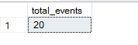
Insight: Overall app engagement baseline.
2. Feature Usage Counts
How many times was each feature used?
Select feature_name, Count(*) as usage_counts
FROM feature_events
Group By feature_name
Order By usage_counts desc
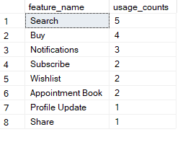
Insight from Feature Usage Counts
- Search is the most frequently used feature, indicating it is the core interaction driving user engagement.
- Buy follows closely, showing strong transactional activity within the app.
- Notifications, Subscribe, Wishlist, and Appointment Book have moderate usage (2–3 times), suggesting users are engaging with these but there is room for growth.
- Profile Update and Share are the least used features (1 time each), indicating these might be underutilized and could benefit from UX improvements or reconsideration.
3. Unique Users per Feature
Select feature_name, Count(Distinct user_id) as unique_users
From feature_events
Group by feature_name
Order by unique_users desc
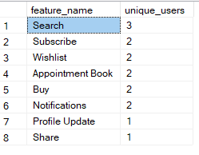
Insight: Identify which features reach most users.
4. Daily Active Users (DAU)
SELECT CAST(event_date AS DATE) AS activity_date,
COUNT(DISTINCT user_id) AS DAU
FROM feature_events
GROUP BY CAST(event_date AS DATE)
ORDER BY activity_date;
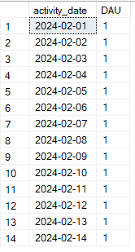
Insight: Tracks daily engagement trends.
5. Events per user
SELECT user_id, COUNT(*) AS events_count
FROM feature_events
GROUP BY user_id
ORDER BY events_count DESC;
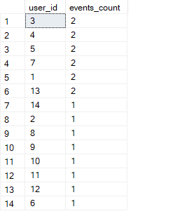
Insight: Identify most active users.
INTERMEDIATE ANALYSIS
6. Power Users (users using 3+ features)
SELECT user_id, COUNT(DISTINCT feature_name) AS features_used
FROM feature_events
GROUP BY user_id
HAVING COUNT(DISTINCT feature_name) >= 2;
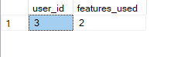
Insight: Users engaging with multiple features → target for premium offerings.
7. Feature adoption over time
SELECT feature_name, CAST(event_date AS DATE) AS date, COUNT(DISTINCT user_id) AS users_count
FROM feature_events
GROUP BY feature_name, CAST(event_date AS DATE)
ORDER BY date, feature_name;
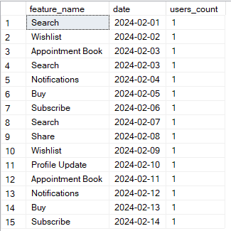
Insight: Track growth/decline in feature usage.
8. Session duration per user
SELECT user_id,
DATEDIFF(MINUTE, session_start, session_end) AS session_duration_minutes
FROM sessions;
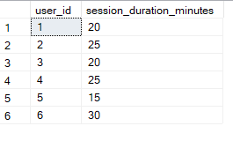
Insight: Longer sessions = higher engagement; compare across users/features.
9. Basic funnel: Search → Buy → Subscribe
SELECT
COUNT(DISTINCT CASE WHEN feature_name='Search' THEN user_id END) AS search_users,
COUNT(DISTINCT CASE WHEN feature_name='Buy' THEN user_id END) AS buy_users,
COUNT(DISTINCT CASE WHEN feature_name='Subscribe' THEN user_id END) AS subscribe_users
From feature_events
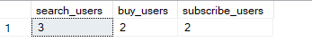
Insight: Initial view of conversion between key features.
ADVANCED ANALYSIS
10. Retention by first feature used (Cohort Analysis)
WITH first_event AS (
SELECT user_id, MIN(event_date) AS first_event_date,
feature_name AS first_feature
FROM feature_events
GROUP BY user_id, feature_name
)
SELECT first_feature, COUNT(user_id) AS users_count
FROM first_event
GROUP BY first_feature
ORDER BY users_count DESC;
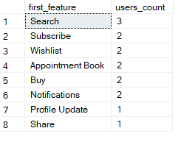
Insight: Identify which first-used feature drives retention.
11. Funnel analysis with conversion rate
SELECT
COUNT(DISTINCT CASE WHEN feature_name='Search' THEN user_id END) AS search_users,
COUNT(DISTINCT CASE WHEN feature_name='Buy' THEN user_id END) AS buy_users,
COUNT(DISTINCT CASE WHEN feature_name='Subscribe' THEN user_id END) AS subscribe_users,
CAST(COUNT(DISTINCT CASE WHEN feature_name='Buy' THEN user_id END) AS FLOAT) /
NULLIF(COUNT(DISTINCT CASE WHEN feature_name='Search' THEN user_id END), 0) AS search_to_buy_rate,
CAST(COUNT(DISTINCT CASE WHEN feature_name='Subscribe' THEN user_id END) AS FLOAT) /
NULLIF(COUNT(DISTINCT CASE WHEN feature_name='Buy' THEN user_id END), 0) AS buy_to_subscribe_rate
FROM feature_events;
Insight: Quantify drop-offs and conversion efficiency.
12. Feature stickiness (users repeating a feature multiple times)
SELECT feature_name, COUNT(*) AS total_events, COUNT(DISTINCT user_id) AS unique_users,
CAST(COUNT(*) AS FLOAT)/COUNT(DISTINCT user_id) AS avg_events_per_user
FROM feature_events
GROUP BY feature_name
ORDER BY avg_events_per_user DESC;
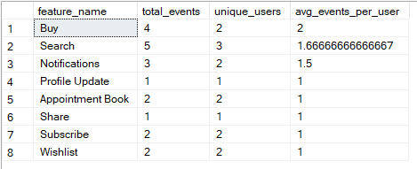
Insight: Identify which features are most engaging per user.

OVERALL FINDINGS:
- Search is the most frequently used feature, indicating it is the core entry point for users.
- Buy and Appointment Booking show strong engagement → users have transactional intent.
- Subscribe feature has low usage → requires better UI visibility or onboarding prompts.
- Feature adoption varies day-by-day, with noticeable peaks — suggests time-based usage patterns.
- Power users (multi-feature users) form a small but highly engaged group → potential premium segment.
- Profile Update and Share are rarely used → these features need UX improvements or reconsideration.
- Conversion from Search → Buy → Subscribe is weak → major drop-off at the Subscribe stage.
- Stickiness analysis shows users repeat Search often → reinforces the importance of search optimization.

Business Recommendations
- Improve the Subscribe flow by placing subscription prompts after appointment or checkout actions.
- Enhance Search reliability since it drives the highest activity — consider autocomplete or filters.
- Redesign underperforming features (Profile Update, Share) or consider merging/removing them.
- Promote high-value features like Appointment Book via push notifications.

Case Study Summary
This project analyzes user behavior in a medical app using SQL across events, sessions, and subscription data. I explored feature-level engagement, adoption trends, funnel performance, and user retention patterns. The analysis reveals Search as the primary engagement driver, low subscription conversion, and underperforming auxiliary features. Final recommendations include improving the subscription experience, optimizing search, promoting high-value features, and redesigning low-usage features to increase overall engagement and revenue.

